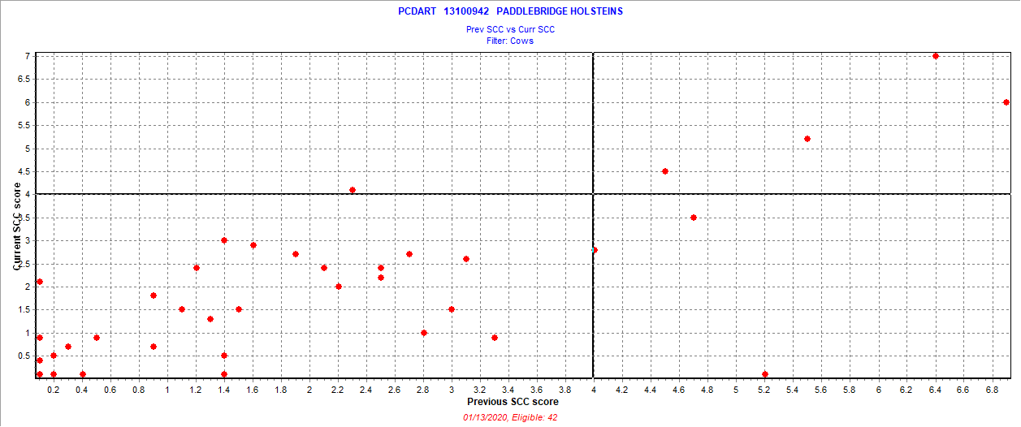

January 6 2020 test date

New = 1 = 2.4%

Chronic = 4 = 9.5%

Cure = 3 = 7.1%

Uninfected = 34 = 81.0%

Also 1 fresh cows SCC > 3.9